Register for the camp in Dolphin Park on the following dates:

DATE OF REGISTRATION | TIME
14th May | 10:00 am
21st May | 10:00 am
11th June | 10:00 am

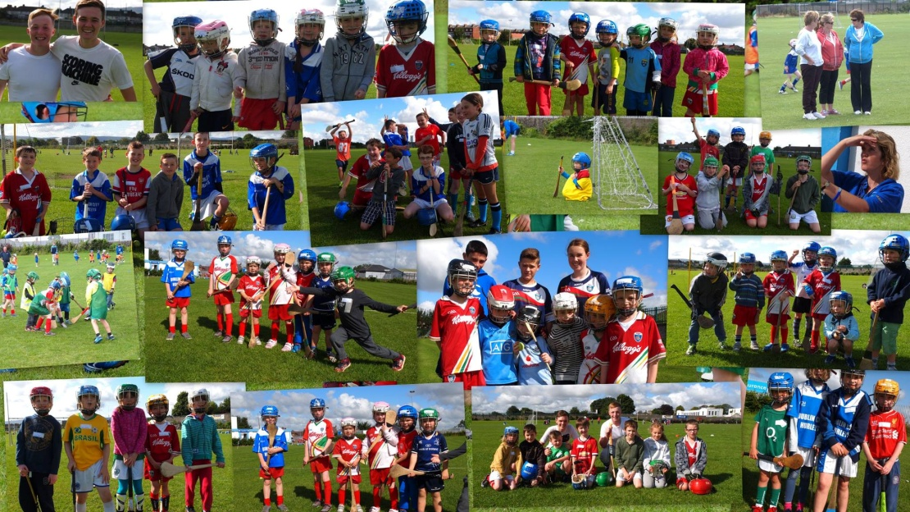

Important to Note:
All children must be registered by the 11th of June (incl.) in order to receive their Kellogg’s kits.

