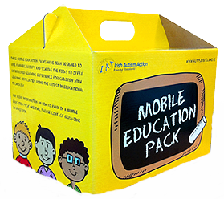
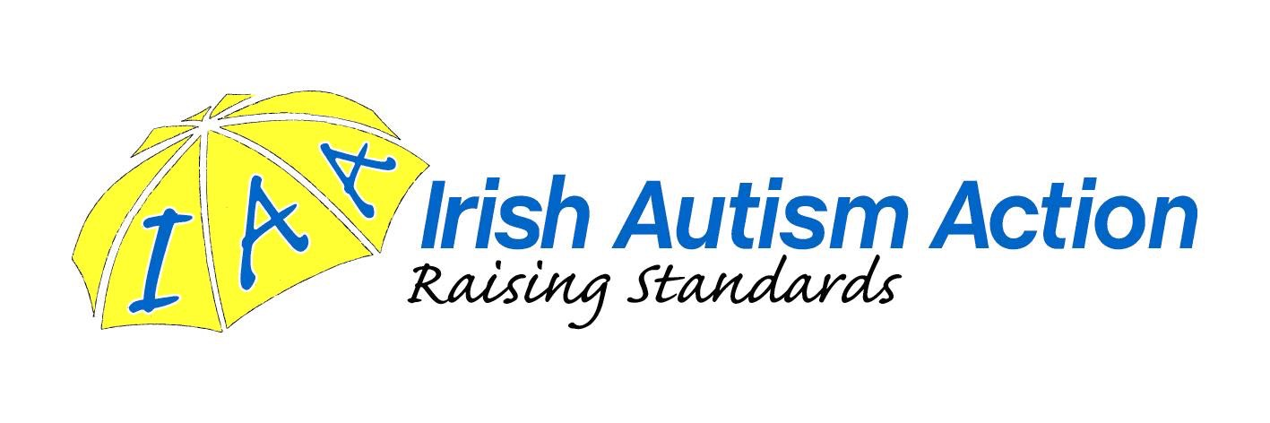

Irish Autism Action Mobile Phone Recycling Appeal

Dear Parent,

We are delighted to tell you that our school has registered to support Irish Autism Action and their Mobile phone recycling appeal this school year.

By donating the phones, not only is the school gaining much needed technology and equipment, we are also doing our bit for the environment. The mobile phones will be exchanged for badly needed resources for our school like iPads, laptops, Defibrillators, sporting equipment etc.

Most of us have old mobile phone lying at the bottom of that drawer, so I would encourage you to take a look in that drawer, cupboard or box, hopefully find a phone, and return it to your child’s teacher. For more information on the campaign go to www.autismirelandphones.ie

Remember by donating the phones you are also helping Irish Autism Action in its mission to raise the quality of life of individuals and their families affected by autism

I hope you will consider donating your old phone to our collection.

Thanking you in advance for your continued support of our school.

Kind regards,

April Cronin

